***Electronics and Communication Department***

***Analog Electronics***

**LAB 1 Notes**

**CE AMPLIFIER**

|  |  |
| --- | --- |
| **Name** | **عبدالرحمن علي موسى** |
| **Sec** | **4** |

* **Dc Measurement**
  + VCE=5.35 v IC=0.69 mA
  + VBE=0.64 v IE=0.70 mA
  + VRC=6.32 v IB=3.28 µA
  + VRE=0.33 v β=210.36
  + α=0.98

* Gain
* Vspp=200 mV Vopp=282 mV
* Av=1.41 v/v Av (dB)=2.98 dB

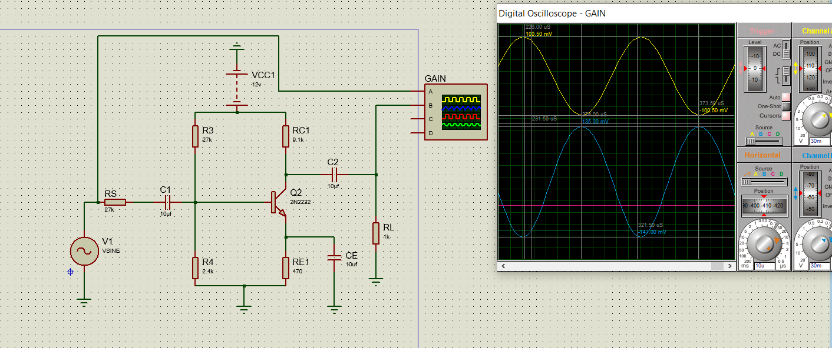

* Rin
* Vxpp=200 mV Vx1pp=185 mV
* Ixpp=0.15mA
* Rin=1.33 KΩ

* Rout
* Vxpp=200 mV Vx1pp=170 mV
* Ixpp=0.3 mA
* Rout=666.6 Ω

